Python HackerRank Questions and Answers

1. Arithmetic Operations

2. IF ELSE

3.Division Operation

4. Squaring

5. Leap Year

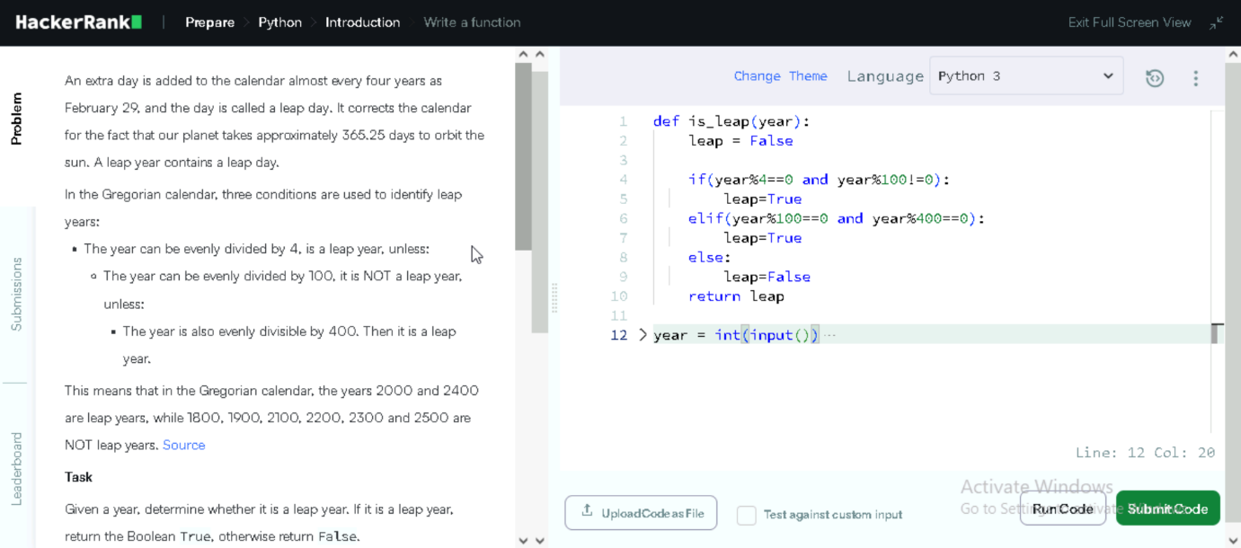

6. List Comprehension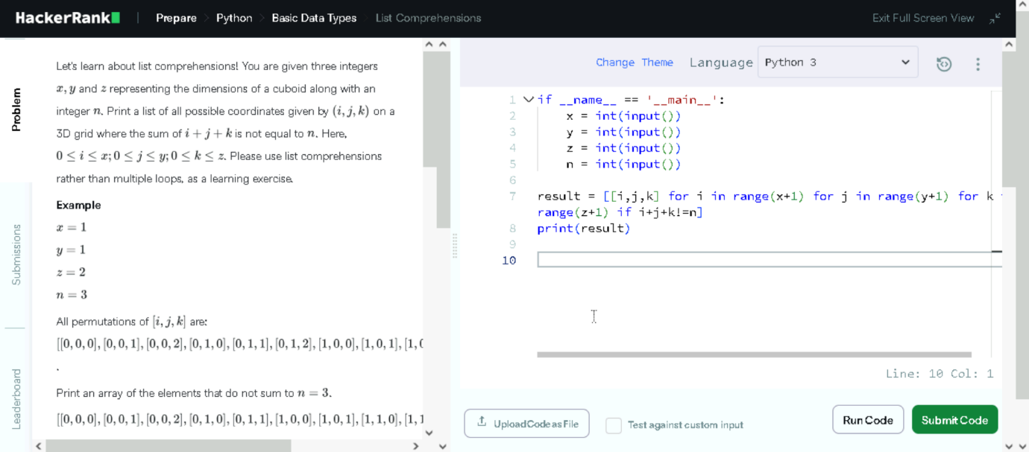

7. Minion Game

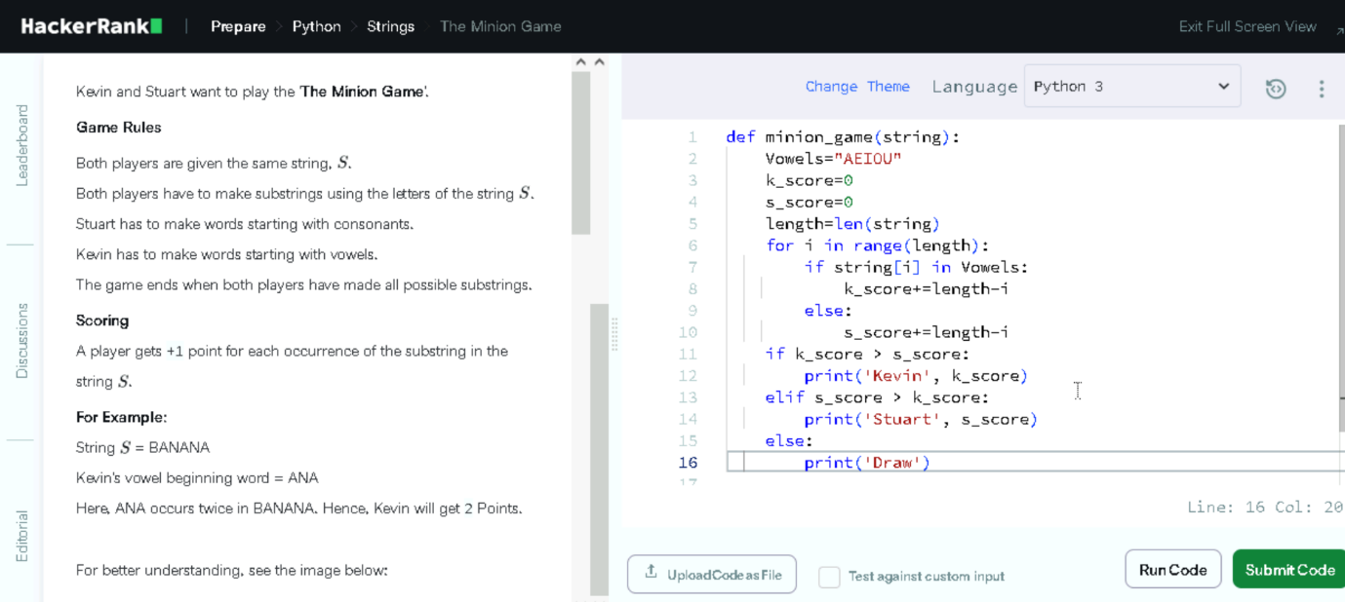

8. Regular expression and index finding

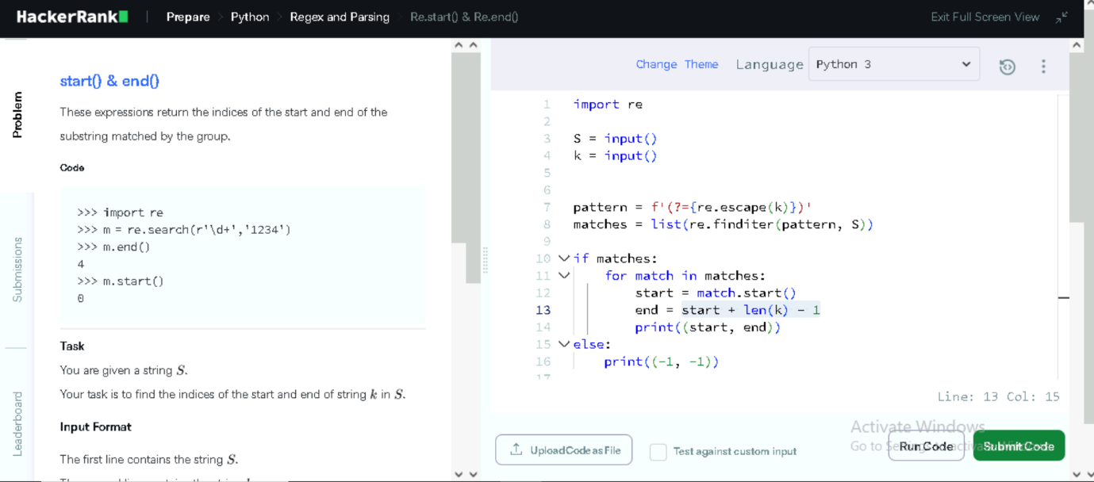

9. Word Count

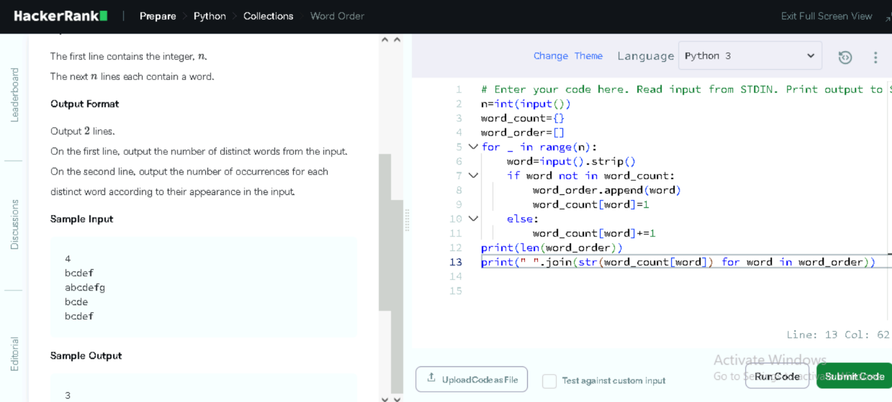

10.Find names of Students having Second Lowest Grade

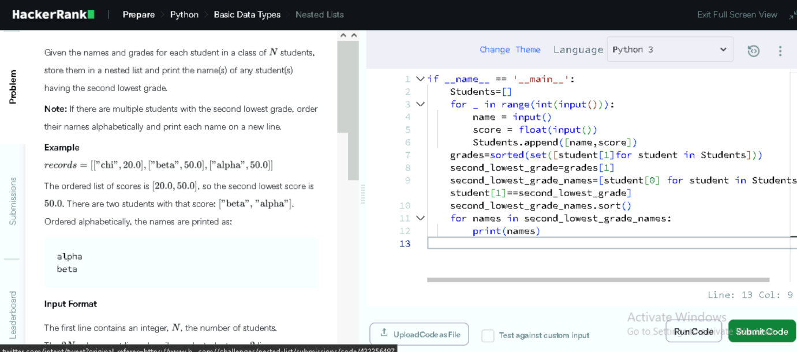

11. Validating Email Address with a filter

